2017 Victorian
Saloon Car Series

Sporting Regulations
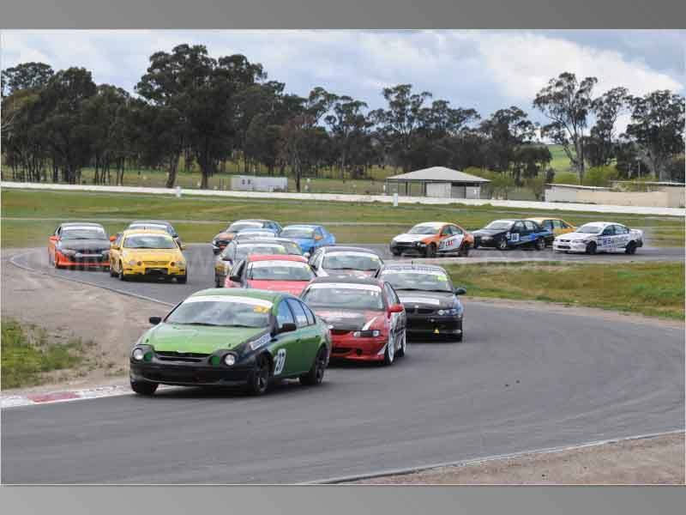

2017 Victorian
Saloon Car Series
Sporting Regulations

S1 |  | TITLE and JURISDICTION | 3
 | S1.1 | Title | 3
 | S1.2 | Authority/Jurisdiction | 3
S2 |  | ADMINISTRATION | 3
 | S2.1 | Personnel | 3
S3 |  | COMPETITOR ELIGIBILITY | 3
S4 |  | AUTOMOBILE ELIGIBILITY | 3
 | S4.1 | Replacement Automobiles | 3
S5 |  | DRIVER ELIGIBILITY | 4
 | S5.1 | Substitute Drivers | 4
S6 |  | SERIES ROUNDS | 4
S7 |  | SERIES CALENDAR | 4
S8 |  | ROUND FORMAT | 4
 | S8.1 | Round Format | 4
 | S8.2 | Variations to Timetable | 4
S9 |  | GRID DETERMINATION | 4
S10 |  | START PROCEDURE | 4
S11 |  | AWARDS and POINTSCORE | 5
 | S11.1 | Prizes and Trophies | 5
 | S11.2 | Series Point score | 5
S12 |  | EVENT OPERATIONS | 6
 | S12.1 | Entry Forms | 6
 | S12.2 | Driver Briefing | 6
 | S12.3 | Impound/Parc Ferme | 6
 | S12.4 | Removal of Automobile from the circuit | 6
S13 |  | FUEL | 7
S14 |  | AUTOMOBILE MARKINGS | 7
S15 |  | IN-CAR CAMERAS | 7
S16 |  | SEALING OF AUTOMOBILES/COMPONENTS | 7
S17 |  | TYRES | 7

S1 TITLE and JURISDICTION
S1.1 Title

This Series shall be known as and referred to as the “2017 Victorian Saloon Car Series”

S1.2 Authority/Jurisdiction

(a) All events in the 2017 Victorian Saloon Car Series will be conducted under the provisions of the International Sporting Code of the Federation Internationale de I’Automobile (FIA); the National Competition Rules (NCR) and Race Meeting Standing Regulations (RMSR) of the Confederation of Australian Motor Sport Ltd (CAMS); the Sporting and Technical Regulations issued for this Series by CAMS and Commercial Arrangements issued for this Series by the Category Manager (as posted on the CAMS website); Supplementary and Further Regulations issued by a promoter at each round; Bulletins issued by the Stewards of the meeting; and any Driver Briefing Notes issued by the Clerk of the Course at a meeting.

(b) This Series has been sanctioned by CAMS as a State Series.

S2 ADMINISTRATION
S2.1 Personnel

The following personnel have been appointed to the Series by CAMS and have the authority to administer the various aspects of these regulations as detailed in the RMSR.

Series Administrator (SA) Daniel Johnson
Category Scrutineer (CS) TBC

Contact Details: Daniel Johnson
Email – deejay098@gmail.com
Web. www.vicsalooncars.com.au

S3 COMPETITOR ELIGIBILITY
To be eligible to compete in the Series, each Competitor must hold a current CAMS Competitor’s Licence and be a financial member of Victorian Saloon Car Association (VSCA).

S4 AUTOMOBILE ELIGIBILITY
Only automobiles that comply with the provisions of the CAMS Manual of Motor Sport – Race – 3rd Category – TOURING CARS – Group 3K Saloon Cars to be eligible to compete in the Series.

S4.1 Replacement Automobiles
Following the commencement of the first qualifying session of each round of the Series, any automobile that has been entered to compete at that round may not be replaced with another automobile.

S5 DRIVER ELIGIBILITY
To be eligible to compete in the Series, each driver must hold a current CAMS Provisional Clubman Circuit (PCC) Licence, a CAMS Clubman Circuit (CC) Licence or higher, and be a financial member of Victorian Saloon Car Association (VSCA).

S5.1 Substitute Drivers
Prior to the commencement of the first qualifying session at each round of the Series, a Competitor may nominate a substitute driver who may be permitted to compete in the remainder of the meeting subject to the approval of the Stewards of the Meeting and the SA.

S6 SERIES ROUNDS
The Series will be conducted over five (5) Rounds as detailed in the Series calendar below. Each race conducted as a part of the Series will count in determining the final results.

S7 SERIES CALENDAR
The Series will be conducted over the following rounds:

Round | Date | Venue
1 | 4 – 5 March | Sandown
2 | 6 - 7 May | Phillip Island
3 | 17 - 18 June | Winton
4 | 22 - 23 July | Sandown
5 | 30 September - 1 October | Phillip Island

S8 ROUND FORMAT
The number, length and format of track sessions will ultimately be negotiated between the SA and the event promoter prior to a round of the Series and will be advised in the relevant Supplementary/Further Regulations issued for the meeting.

S8.1 Round Format
Generally, the format for each round of the Series will be a minimum of as follows:
- Qualifying - One (1) qualifying session.
- Races - Three (3) or four (4) 15 minute races (approximately) expressed as a number of laps.

S8.2 Variations to Timetable
The timetable may be varied at any time due to exceptional circumstances only with the prior approval of the Stewards of the Meeting.

S9 GRID DETERMINATION
The grid for each race will be determined as detailed in the RMSR – Progressive Grid.

S10 START PROCEDURE
The start procedure for each race will be as detailed in the RMSR

S11 AWARDS and POINTSCORE
S11.1 Prizes and Trophies
Prizes, trophies and awards will be as determined by the SA and will be advised to all Competitors.

S11.2 Series Point score
- Points shall be awarded to drivers for each race in the Series as follows:

3 Race Format

Finishing Position | Points | Finishing Position | Points
1st | 40 | 11th | 10
2nd | 35 | 12th | 9
3rd | 31 | 13th | 8
4th | 27 | 14th | 7
5th | 23 | 15th | 6
6th | 20 | 16th | 5
7th | 17 | 17th | 4
8th | 15 | 18th | 3
9th | 13 | 19th | 2
10th | 11 | 20th to last | 1

4 Race Format

Finishing Position | Points | Finishing Position | Points
1st | 30 | 11th | 7.5
2nd | 26.25 | 12th | 6.75
3rd | 23.25 | 13th | 6
4th | 20.25 | 14th | 5.25
5th | 17.25 | 15th | 4.5
6th | 15 | 16th | 3.75
7th | 12.75 | 17th | 3
8th | 11.25 | 18th | 2.25
9th | 9.75 | 19th | 1.5
10th | 8.25 | 20th to last | 0.75

- Points will only be awarded to drivers classified as finishers in the final results of each race.

- The results for each round of the Series will be determined by the number of points scored by each driver at that round. In the event of a tie at the end of any round of the Series, the final positions for that round will be determined by comparing the results of each of the tied drivers in the final race of that round. The higher place in the round results will be awarded to the higher placed finisher in the final race.

- The Victorian Saloon Car Series for each Class will be scored from all (5) five points scoring rounds of the year.

- The driver gaining the highest points total over the (5) five rounds shall be declared the winner of the Series.

- In the event of a tie at the end of the Series, final positions will be determined by comparing the race results achieved by each tied driver, with the driver with the highest number of first places being awarded the higher Series position. If at this stage a tie still exists, it will be resolved by comparing the number of second, third or fourth places (and so on) achieved by each tied driver until all positions have been determined.

- To be eligible for series points each driver must use a Front Head Restraint ('FHR'). FIA approved FHR devices are prescribed in the following technical bulletins:
• Technical List No 36- List of FIA Approved Frontal Head Restraint Systems (styles)
• Technical List No 41- List of Helmets Compatible with FHR Systems
• Technical List No 29- List of FIA-Approved FHR Systems According to FIA Standard 8858-2010

- For the driver to be eligible for series points the car must be fitted with 1 or more fire extinguishers, that meet the Speed event criteria in the CAMS General Requirements for Cars and Drivers Schedule H: Fire Extinguishers.
Standards required to meet: AS1841 Except AS1841.2
Minimum total capacity: 900g

S12 EVENT OPERATIONS
S12.1 Entry Forms
Race Meeting entry forms will be available via mail, email, or for download from the Victorian Saloon Car website. (http://vicsalooncars.com.au)

S12.2 Driver Briefing
Each Driver must attend the compulsory Driver’s briefing. The time and location of this briefing will be detailed in the Supplementary or Further Regulations for the meeting. The attendance sheet must be signed by the Driver to confirm attendance. Other compulsory briefings may be convened as required and will be advised to all Competitors accordingly.

S12.3 Impound/Parc Ferme
- At the conclusion of qualifying each automobile, including those remaining in pit lane, must proceed directly to the designated impound/Parc Ferme area via the most direct route (or as directed by Race Officials), without returning to the pit or paddock areas and without interference from any third party (other than an Official of the Meeting).

- At the conclusion of each race each automobile completing that race must proceed directly to the designated impound/Parc Ferme area (or as directed by Race Officials), without returning to pit or paddock areas and without interference from any third party (other than an Official of the Meeting).

- Automobiles may not be removed from impound/Parc Ferme except with the express permission of the Chief Scrutineer.

S12.4 Removal of Automobiles from the circuit
Following the commencement of the first qualifying session, it is not permitted to remove any automobile from the circuit (prior to the release of all automobiles from the designated impound /Parc Ferme area following the final race of that round of the Series) without the prior express written approval of the CS.

S13 FUEL
For the duration of any meeting, Competitors must only use fuel that complies with the definition of Commercial Fuel as defined in the CAMS Manual of Motor Sport.
Please note: With the exception of ambient atmospheric air and the fuel as specified above, no other substance may be added to the intake charge of the engine.
At meetings where a control fuel is mandated by the event organiser, the control fuel is to be used.
At all rounds for the duration of each meeting, Championship class and the new VY and BA, competitors must only use fuel as supplied by the official fuel supplier at the meeting, as detailed below:
Cheetah Race Fuels – Mario Gaffiero
(03) 9311 5729 – sales@cheetahracefuels.com.au

S14 AUTOMOBILE MARKINGS
Each automobile must display the following Series markings, appropriately attached and positioned as detailed below, at all times during each round of the Series. The Series markings will be provided by the SA.
- Front windscreen strip = Sponsor Name (upper portion of front windscreen)
- Rear windscreen = Sub-sponsor Name
- A Bridgestone decal on each front mudguard
- A Pedders Suspension decal on each front or rear mudguard
- A CAMS decal adjacent to the number panel on each front door
- Category Sponsor Decals must be displayed in a clear and visible area, or as instructed by the SA.
Each Automobile is required to display a decal in a contrasting colour on either side of the rear quarter of the automobile indicating the State or Territory of origin of the driver eg. VIC. Letters must be a minimum of 100mm in height.

S15 IN-CAR CAMERAS
In-car cameras are permitted, subject to their instillation being approved by the Chief Scrutineer.

S16 SEALING OF AUTOMOBILES/COMPONENTS
- The engine, gearbox, final drive assembly and ECU fitted to each automobile must have been sealed by a nominated sealer approved by the Saloon Car Racing Association (SCRA), with seals supplied by SCRA, prior to the commencement of qualifying at each round of the Series.
- Where a sealed component has been determined to be ineligible by the Stewards of the Meeting, the Stewards of the Meeting may, at their discretion, exclude the automobile from the results of all previous rounds of the Series in which the sealed component was identified as having been used on that automobile.

S17 TYRES
- Each automobile must be fitted with tyres as detailed below at all times during each round of the Series:
- Bridgestone Potenza RE11 Type SR2, 235/50 R16, 235/45 R17 and 245/40 R18.
- At the first round of the Series a maximum of four (4) new tyres and two (2) used tyres per automobile shall be permitted for use during qualifying sessions and races.
- At each subsequent round of the Series, a maximum of two (2) new, and four (4) previously marked tyres are permitted for use during qualifying sessions and races.
- For automobiles competing in their first round in the Series, except round 1, a maximum of four (4) new tyres and two (2) used tyres per automobile shall be permitted for use during qualifying sessions and races at that round.
- The use of unmarked tyres during qualifying or races is not permitted.
- The nominated tyres for marking must be presented at the front of the garage, carport or allotted car space for marking no later than 30 minutes prior to the start of the first qualifying session. Each Competitor is responsible for ensuring that each tyre is marked or re-marked as appropriate.
- Replacement tyres shall only be permitted with the prior express approval of the CS. If a marked tyre is replaced after the commencement of the first qualifying session, the automobile must start the next race from the rear of the grid.
Please note: The CS shall be sole arbiter with regard to the interpretation and application of these tyre regulations. Any decision made by the CS in this regard shall not be the subject of any protest or appeal.

